RESEARCH CONFIDENTIALITY AGREEMENT
Project title: Combatting Antimicrobial Resistance in Uganda: A Data-Driven Approach to Optimize Antibiotic Use and Improve Patient Outcomes (Project 3 of CAMO-Net Uganda)
As a member of this research team, I understand that I may have access to confidential information about study sites and participants. By signing this statement, I am indicating my understanding of my responsibilities to maintain confidentiality and agree to the following:
- I understand that names and other identifying information about study sites and participants are completely confidential.
- I agree not to divulge, publish, or otherwise make known to unauthorized persons or the public any information obtained during this research project that could identify the persons who participated in the study.
- I understand that all information about study sites or participants obtained or accessed by me during my work is confidential. I agree not to divulge or otherwise make known to unauthorized persons any of this information unless specifically authorized to do so by approved protocol, Infectious Diseases Institute leadership, or the principal investigator acting in response to applicable law or court order or public health or clinical need.
- I understand that I am not to ask study participants questions for my personal information but only to the extent and to perform my assigned duties on this research project.
- I agree to store confidential project information securely and safeguard project information when in use
- I agree to notify the principal investigator and Infectious Diseases Institute Research leadership immediately should I become aware of an actual breach of confidentiality or a situation that could potentially result in a breach, whether on my part or the part of another person.
_____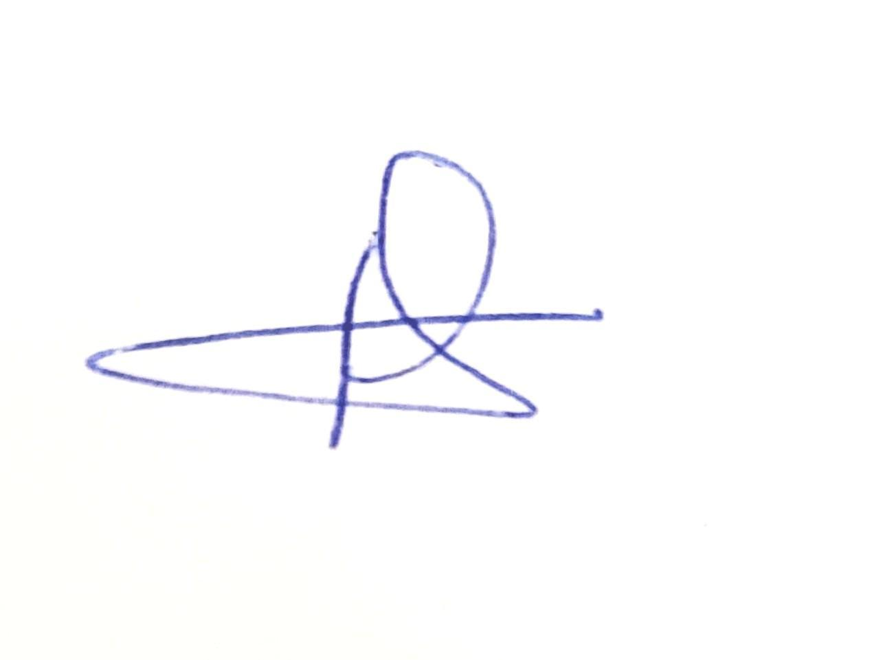___________15/Jan/2025_____Racheal Claire Kyomukama_____
Signature of Staff Date Printed name
___________________________________________________________________
Signature Head of Research Date Printed name

